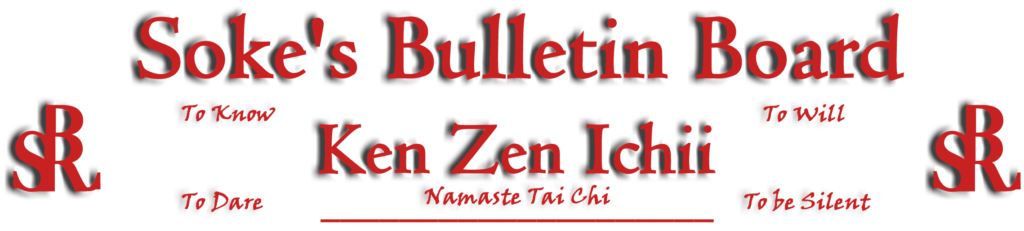
www.kenzenichii.com

January 2010
Promotions
Crush Fitness
Congratulations to Morgan Blatz on earning her Green Belt

House of Soke II
Congratulations to Kyoshi Brown (Army) and Sensei Wilson (Air Force) as they serve our country in the Armed Forces Reserves. Their dedication is a representation of their commitment to the martial arts.

After a 20 + year absence from active duty military service, on December 14, 2009 Sensei Wilson joined the Air Force Reserve to serve along with his son, Brandon, who has already served for several years. Sensei Wilson credits the House of Soke with helping him keep physically eligible for military service.

Crush Fitness
There will be a 2nd Degree Black Belt Test for Sensei JJ Liggera on Sunday, January 10 at 12:00pm.

A Brown Belt Test for Lucas Acampora is scheduled for Friday, January 15 at 6:00pm and a Yellow Belt Test for Nicholas Bisceglia is scheduled for Saturday January 30 at 11:30am.

There is now a White Belt class every Sunday at 12:00pm

BSR Modern Martial Arts School
BSR MMA would like to wish all in the system a happy New Year.

KZI Skull & Fist Patches are back. They will be available for a limited time. Please contact BSR MMA if you are interested in purchasing one of these patches.

A video of the Ken Zen Ichii Jujitsu seminar will be available this month.

Two Skies School of Self Defense
Happy holidays to everyone in the Ken Zen Ichii family.

Sapphire Dragons
All is well with the Sapphire Dragons students.

Wishing everybody good health and prosperity for the New Year.

Pearl’s of Wisdom

Why do we KIA?

The KIA is described as a yell or shout that you hear when martial artists are executing technique. KIA means to focus all of your strength, will, and intention at an object or opponent. Ki means “life force”. This energy is believed to be the life force of an individual and can be used for good or bad purposes; Energy is Energy. It’s how it’s focused and the intent behind it. When you apply the KIA to any technique, it becomes stronger and so do you. Why use the KIA? 1)To focus energy at the object being hit; 2)To startle your opponent which may give you a possible advantage; and 3) To stimulate your breathing during a stressful confrontation. It’s not everyday the average person hears the KIA.

The KIA will also cause the person to get “psyched out” causing one to tap into their will. A proper KIA should not come from the throat but from the lungs. When you perform a KIA you are tightening your abdominal muscles and exhaling from your diaphragm, expelling all of the air in your lungs. Also by having the air completely exhaled from your lungs and your abdominal muscles are tight, you are more likely to take a strike with less chance of injury…Sensei Baker

